Algorithms and Data Structures Enhancement – Pirate Intelligent Agent
Brandon Shank
Date: 05/27/2026

Artifact Description
The artifact I worked on for this enhancement is the Pirate Intelligent Agent project that I originally created in CS-370. The purpose of the system is to train an intelligent pirate agent to navigate through a maze environment and successfully reach a treasure using reinforcement learning techniques. The project uses deep Q-learning, neural networks, replay memory, and reward-based learning to allow the pirate agent to improve its decision making over time.
In the original version of the project, most of the code was contained inside a Jupyter Notebook. While the system was functional, the project structure made the code harder to organize, test, and maintain as additional features were added. The original implementation also provided limited training analysis and performance tracking, which made it difficult to fully evaluate how well the reinforcement learning system was performing.
Because of these limitations, this project was a strong candidate for enhancement.

Justification for Inclusion and Enhancements
I chose this project because it demonstrates advanced algorithmic concepts, reinforcement learning, neural networks, and decision-making systems. The project is also effective at solving problems using artificial intelligence and data-driven learning techniques.
I selected this artifact for another reason - it gave me a chance to make meaningful improvements instead of only changing how the project looked visually. The original project worked correctly, but several areas could be improved related to organization, maintainability, testing, performance evaluation, and validation logic.
For the updated version, I focused on improving the reinforcement learning system, project structure, and overall evaluation process. Some of the main changes I made were:
• Converted the original notebook implementation into a modular Python project using separate .py files.
• Added a cleaner project structure using dedicated files for training, metrics, configuration, and execution logic.
• Added performance tracking for loss, rewards, steps, epsilon values, and win rates during training.
• Implemented automated graph generation to visually track learning progress over time.
• Added CSV metric exports so training results can be analyzed outside the program.
• Improved completion validation by checking whether the pirate agent could consistently solve the maze from multiple valid starting positions instead of relying only on recent win percentages.
• Added configurable hyperparameters including epsilon decay, replay memory settings, and target network synchronization frequency.
• Added automatic model saving using the Keras .keras format so trained models can be reused later without retraining.
• Improved comments, readability, debugging support, and overall maintainability.
These changes helped organize the project, improve measurable evaluation, and create a structure that more closely reflects how reinforcement learning projects are developed in professional environments.

Course Outcomes
This project helped demonstrate how algorithms and data structures can be used through reinforcement learning, replay memory systems, neural networks, and decision-making logic. The pirate agent had to evaluate the current state of the maze, select actions, process rewards and penalties, and improve performance through repeated training episodes. This demonstrated measurable learning improvement throughout the training process.
One of the main goals for this enhancement was improving evaluation and maintainability, and I was able to accomplish that by restructuring the project into modular Python files and adding detailed training metrics and validation logic.
The updated version also demonstrated the use of modern tools and technologies including Python, TensorFlow, Keras, neural networks, and reinforcement learning systems. Adding graphs, CSV reports, and completion validation improved the overall testing and evaluation process and made the training results easier to analyze.
Another important outcome demonstrated through this enhancement was improving reliability and reducing logical flaws. The updated completion validation process improved the reinforcement learning system by verifying that the pirate agent could consistently solve the maze from multiple valid starting positions instead of relying only on recent successful training runs.

Reflection
One thing that stood out to me during this enhancement was how important evaluation and validation are in reinforcement learning systems. In the original project, the system mainly relied on recent win percentages to determine success, but during testing I realized that high win rates did not always mean the model had fully learned the maze correctly.
By implementing stricter completion validation, I was able to better evaluate whether the pirate agent could consistently solve the maze in different scenarios instead of only succeeding during recent training runs. This helped improve the reliability of the reinforcement learning system.
Another major improvement involved reorganizing the project structure. Converting the notebook implementation into separate Python files significantly improved the project. Separating the training logic, configuration settings, metrics tracking, and execution logic created a cleaner and more professional structure that was easier to debug, maintain, and improve.
One challenge I faced during this enhancement was configuring the TensorFlow environment and ensuring all dependencies worked correctly inside Visual Studio Code. I also had to troubleshoot training behavior and adjust hyperparameters to improve reinforcement learning performance and stability.
Another challenge involved balancing training efficiency with validation reliability. Some training runs reached high win rates but still failed the stricter completion checks. This demonstrated the importance of thorough validation instead of relying only on basic success measurements.
Overall, this enhancement helped improve my understanding of reinforcement learning, neural networks, project organization, debugging, performance analysis, and algorithm evaluation. It also demonstrated the importance of maintainability and measurable testing when improving existing software systems.

Evidence (Screenshots)

Figure 1: Enhanced Project Structure
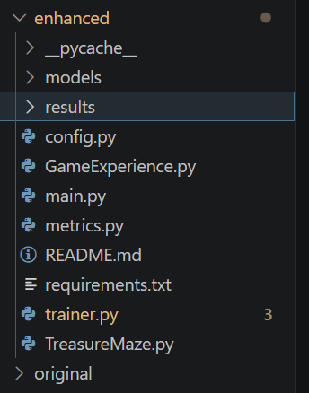
Enhanced modular Python project structure showing separated files for training logic, metrics tracking, configuration management, model storage, and result generation.

Figure 2: Training Execution Output 1
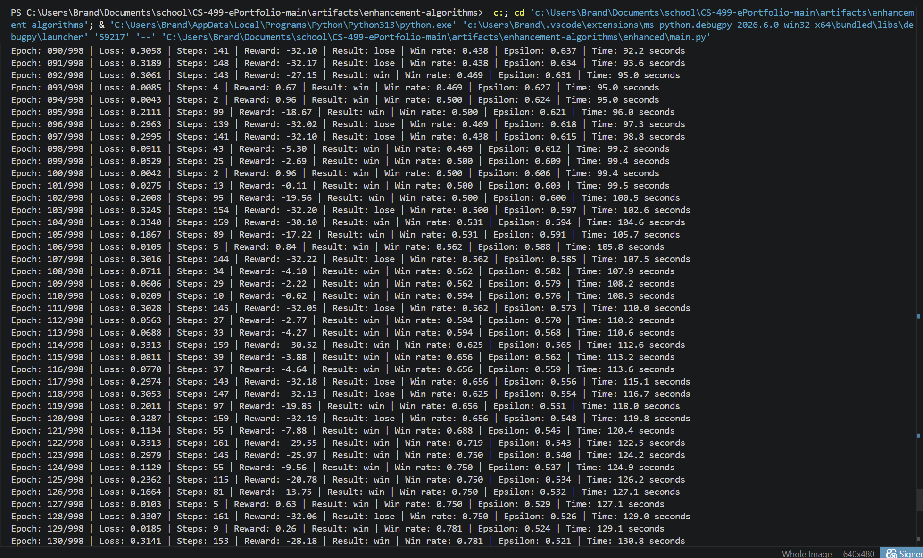
Terminal output showing reinforcement learning training progress including loss values, rewards, steps, epsilon decay, and win-rate tracking during training episodes.

Figure 3: Training Execution Output 2
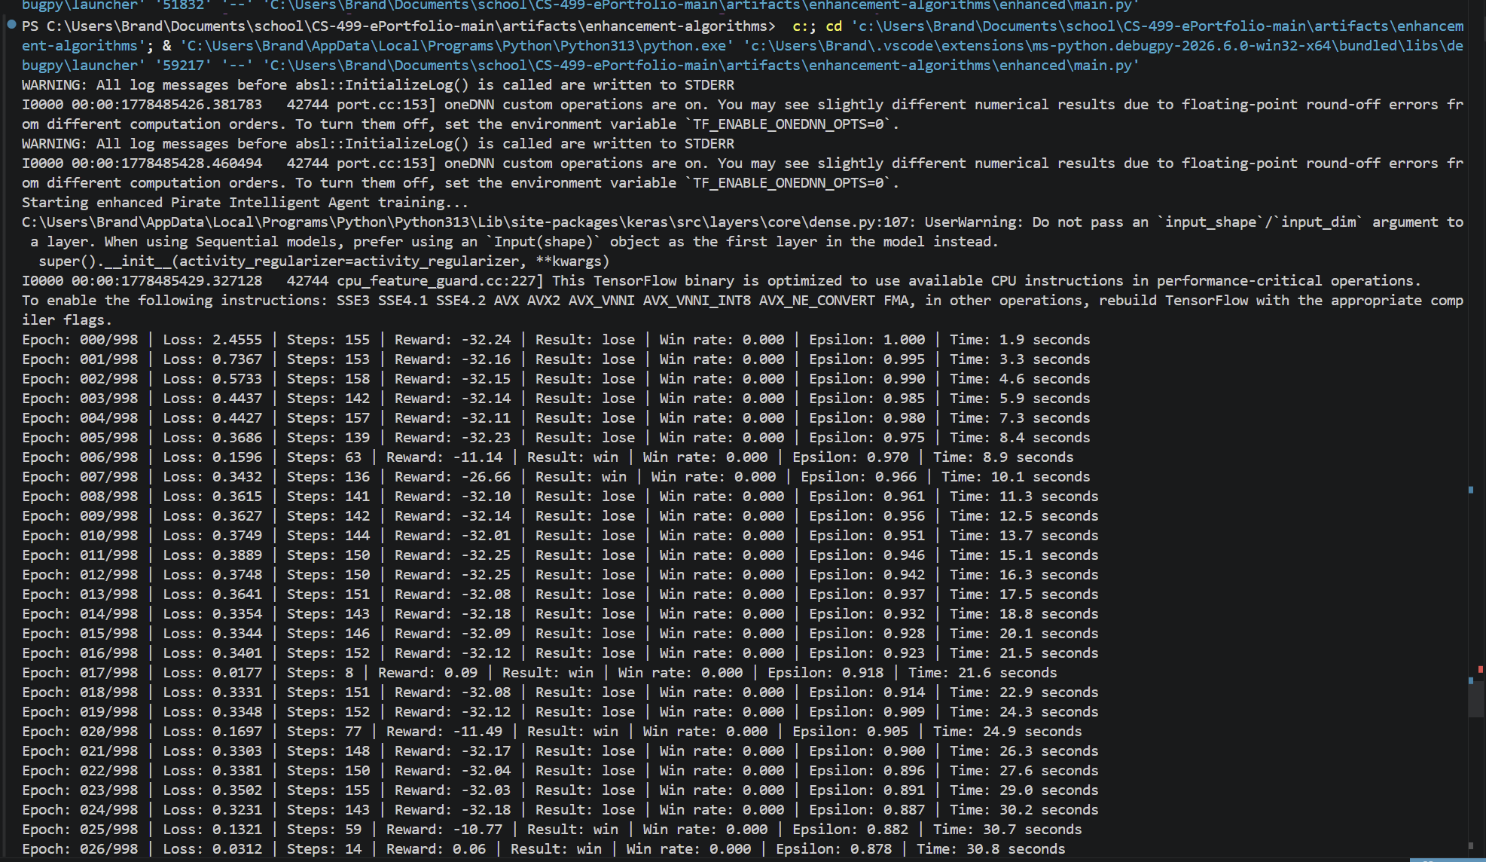
Additional reinforcement learning training execution demonstrating continued learning progression and improved performance metrics over time.

Figure 4: Completion Validation Output
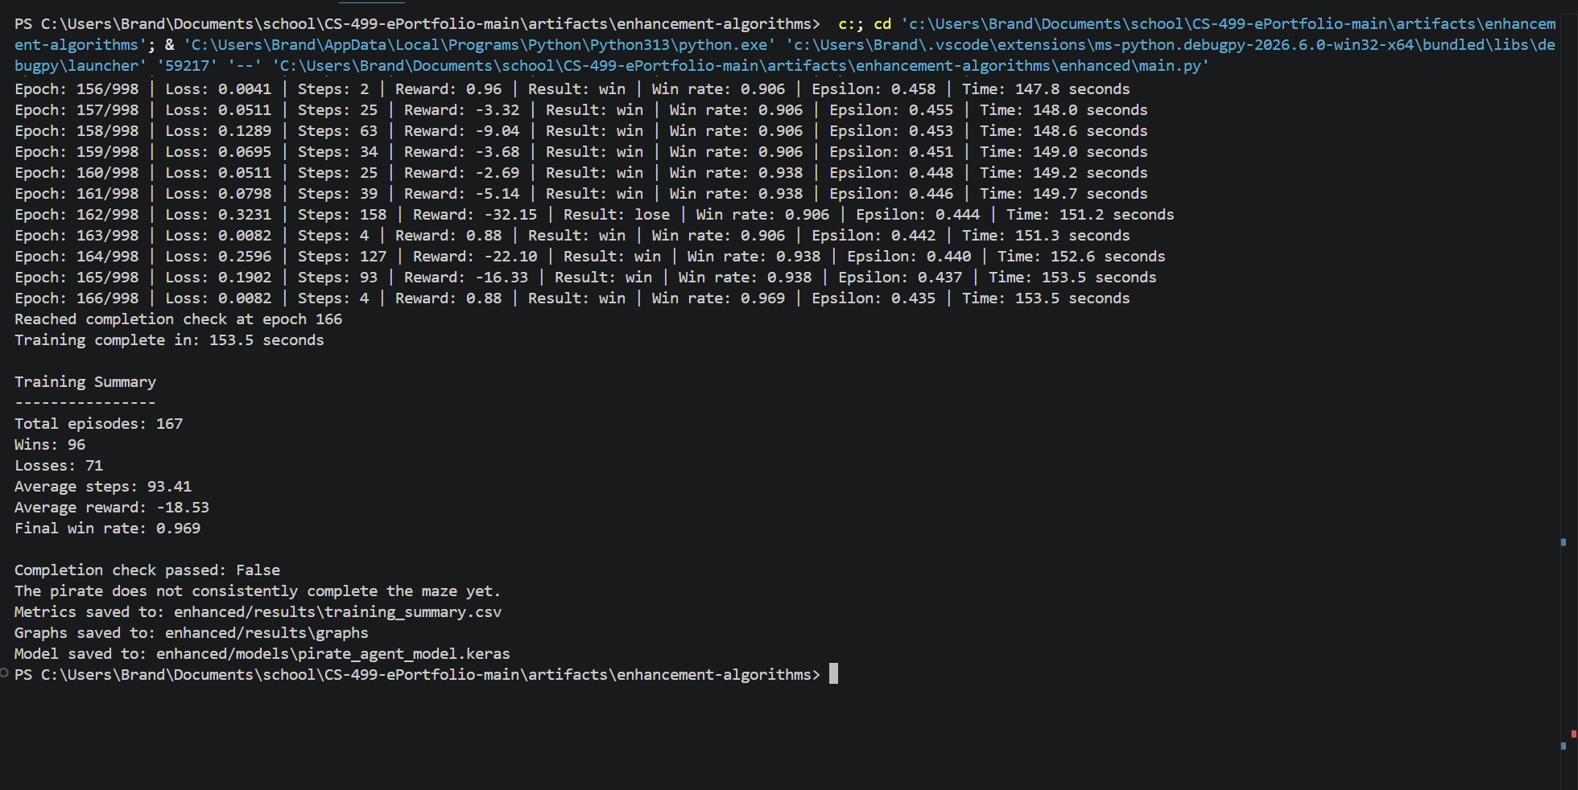
Training summary and completion validation output demonstrating enhanced evaluation logic, win-rate reporting, and reinforcement learning performance analysis.

Figure 5: Loss by Episode Graph
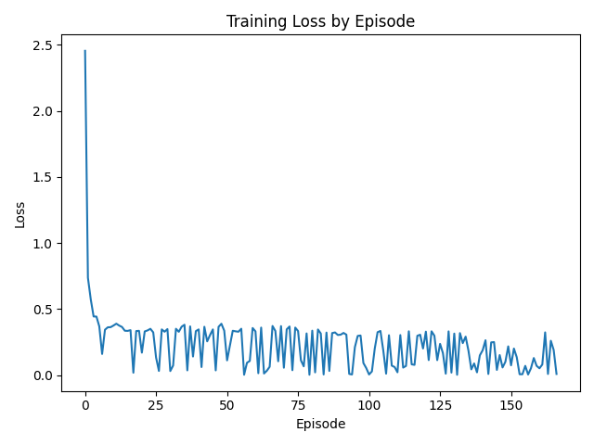
Generated graph showing training loss stabilization throughout reinforcement learning episodes, demonstrating learning progression and model improvement.

Figure 6: Reward by Episode Graph
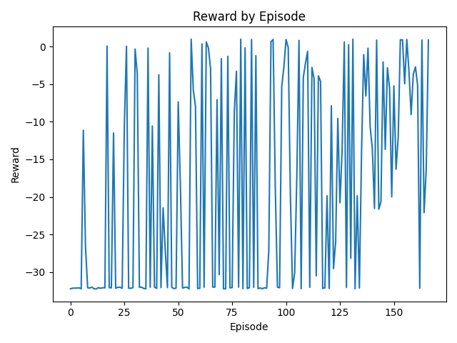
Reward-tracking graph showing reinforcement learning reward progression during training and improved decision-making performance over time.

Figure 7: Steps by Episode Graph
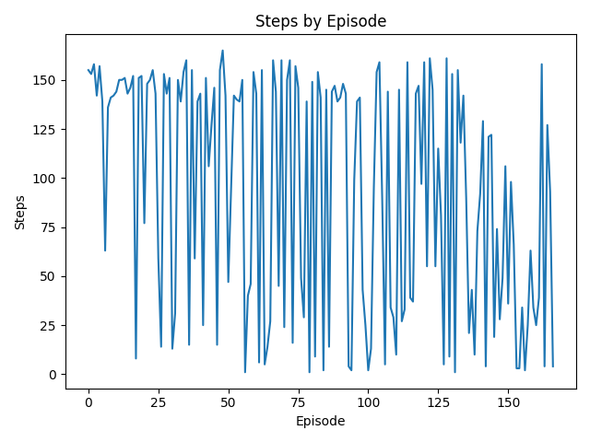
Graph showing the number of steps taken during training episodes, demonstrating movement efficiency improvements as the pirate agent learned the maze environment.

Figure 8: Win Rate by Episode Graph
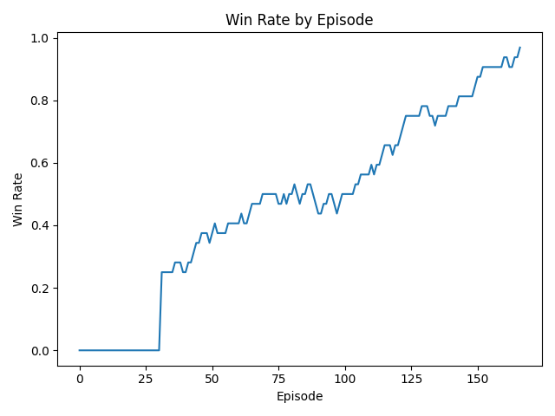
Win-rate progression graph demonstrating reinforcement learning improvement and increasing training success over time.

Figure 9: CSV Metrics Export
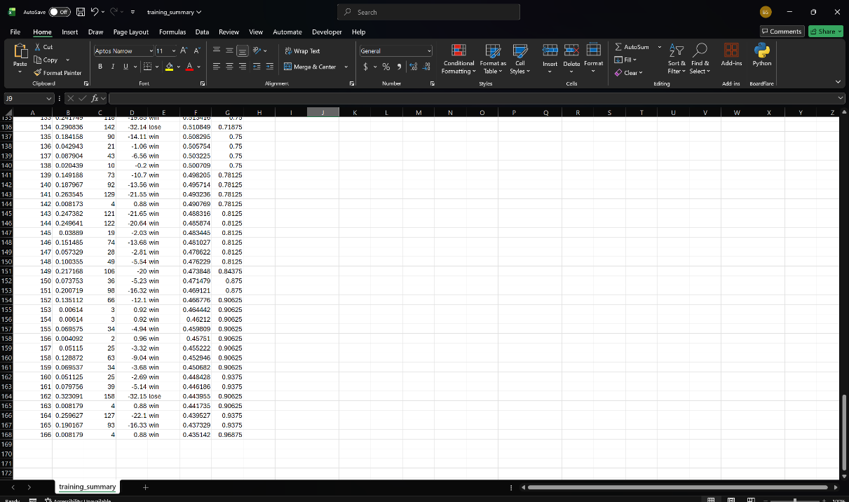

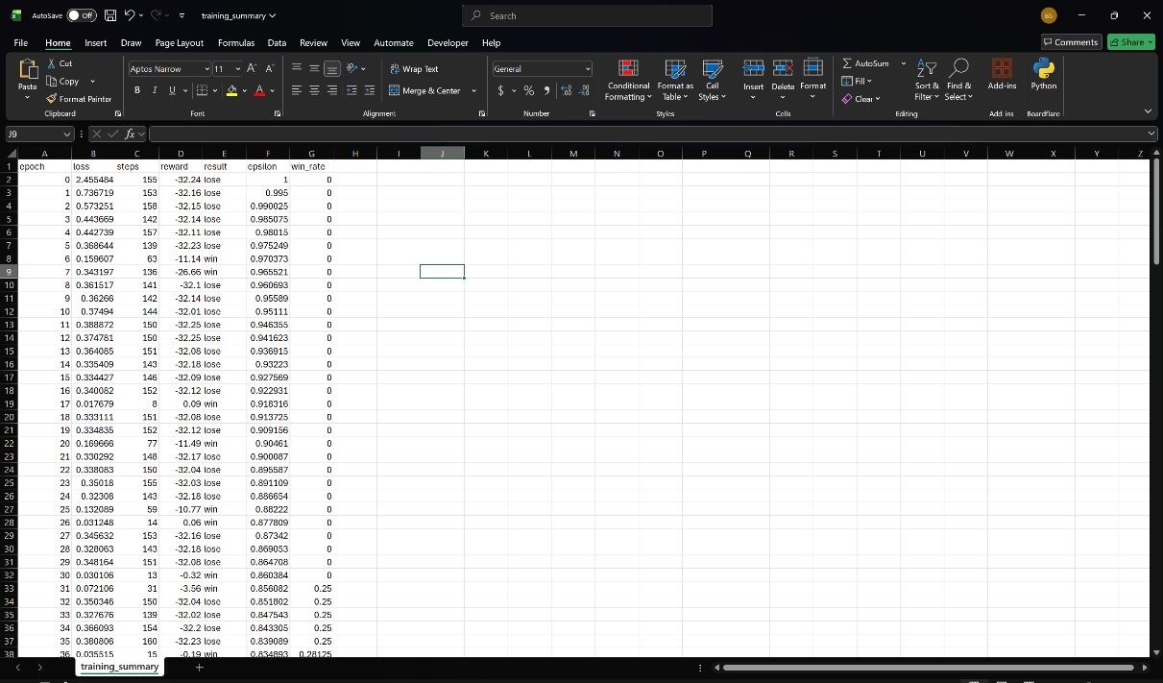
CSV metric export showing recorded training data including epochs, loss values, rewards, epsilon values, and win-rate tracking for reinforcement learning analysis.

Figure 10: Saved Model Output
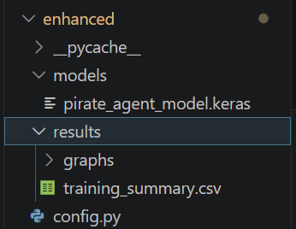
Saved Keras reinforcement learning model demonstrating model persistence and reusable trained neural network output.

